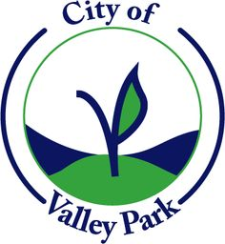
CITY OF VALLEY PARK
FINANCE, WAYS AND MEANS COMMITTEE MEETING VIA ZOOM
AT 6:00 P.M. ON MAY 21, 2020
VALLEY PARK CITY HALL, 320 BENTON STREET, VALLEY PARK, MISSOURI 63088

**** AGENDA****

- PLEDGE OF ALLEGIANCE
- ROLL CALL
- NEW BUSINESS
  - Health Insurance Renewal
  - St. Louis County Police Contract
- ADJOURNMENT

