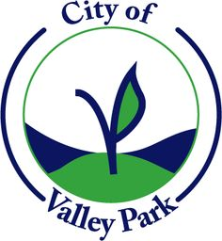
CITY OF VALLEY PARK
FINANCE, WAYS AND MEANS COMMITTEE MEETING VIA VIDEO CONFERENCING (ZOOM)
PURSUANT TO RSMO 610.015
AT 7:00 P.M. ON AUGUST 18, 2020
VALLEY PARK CITY HALL, 320 BENTON STREET, VALLEY PARK, MISSOURI 63088

**** AGENDA****

- PLEDGE OF ALLEGIANCE
- ROLL CALL
- NEW BUSINESS
  - Sanitation Discussion
- ADJOURNMENT

